# Chapter 2.2: Analysis Methodology

Methodology is defined as the systematic and theoretical analysis of the methods applied to a field of study. This also refers as the steps that we need to follow while undertaking a project and the process that must be followed during it. **Analysis Methodology** whereas refers to the various steps taken to collect information, analyzing that information and the providing a document containing the requirement. For choosing what analysis methodology to be selected in doing any project we must know about various factors like how efficient it is, is it functional, is it accurate, is it ease to use, how reliable it is and so on. While focusing on these factors any analysis methodology chosen for the project will be able to provide the requirement information.

For my project ***Nepal Handicraft Online Market,*** I choose ***Hard Approach methodology*** as the main methodology. This approach refers as taking a highly structured approach to the analysis of information system that follow logical sequence of steps and adheres to rules, guidelines and standards. My project is small so this approach is perfect for my system. This approach follows the SSADM (Structured Systems Analysis and Design) method. For this method we have to create and design the Data Flow Diagram (DFD) which show how the system work. This approach ensures thorough planning and scheduling and also is easy to measure the progress of the work that can be shown through each step. I chose this methodology because of the merits it has for my system as this follow a waterfall model where you don’t go forward until you finish the step as a result, we get a better system.

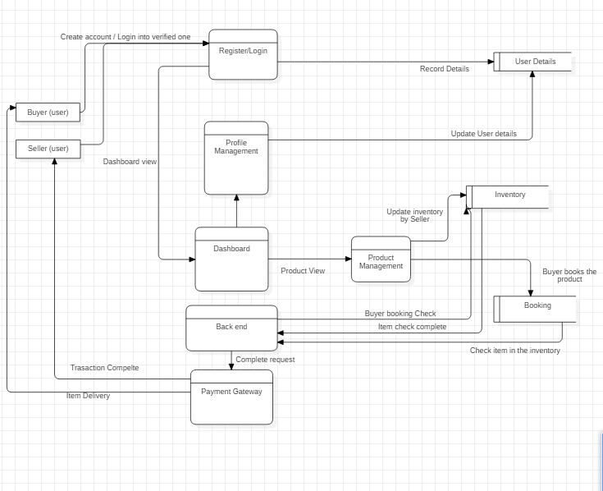

Figure 1: Data Flow Diagram for User

The following data flow diagram show how the user use the system. This DFD shows how the system process flow from one part to another with detail information on the working mechanism. This helps to get the grasp of the system process.